Undergraduate Research Opportunity for Pay or Credit
Investigate relationships between online communities


Online communities are increasingly important to communication and society. In the online ecosystem different communities can share members, have overlapping topics, and learn from each other. The Community Data Science Collective is studying ecological models of how relationships between different online communities shape their growth and development. Help us answer research questions like “When do online communities compete?” “What do they compete over?” and “How can related online communities mutually support one another?”

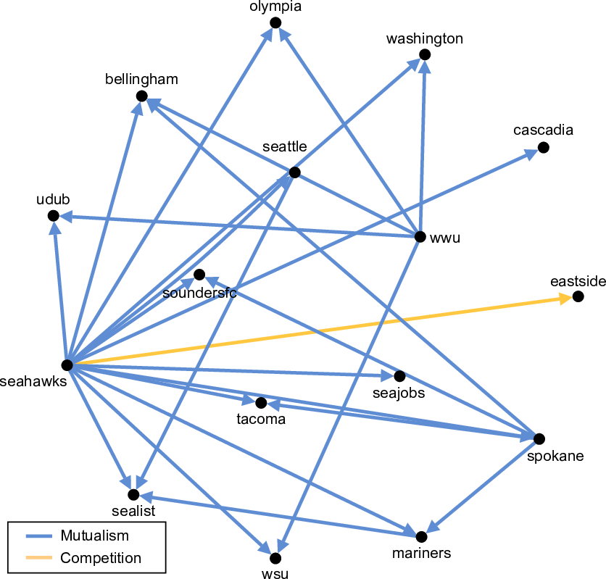
As a member of this research group you will contribute to a mixed-methods investigation of networks of related subreddits. You will help conduct qualitative research to learn what makes different subreddits special and how they relate to each other. You will also synthesize your results with findings from a parallel computational analysis to generate new theories of online community ecology.

The research group will be organized by Benjamin Mako Hill and Nathan TeBlunthuis. NSF research funding is available to pay one or two students at $16.60/hour. Applicants interested in working for academic credit are welcome.

Prerequisites: This opportunity is available to University of Washington undergraduate students with strong reading and writing skills in the English language, ability to attend online video-chat team meetings, a commitment to produce high-quality results, and availability to work 10 hours/week through June 2021. Funding is only available for U.S. citizens or permanent residents. Experience in social scientific research methods (such as COM 301) and/or familiarity with Reddit is strongly desired.

Applying: Submit a cover letter and resume to nathante@uw.edu. The resume should include recent and relevant courses and work experience. The cover letter should describe your experience with online communities or social media and explain why you'd like to participate, including your academic or career interests and what you hope to learn. Please indicate if you want to work for pay or academic credit.

