COM590 Learning Contract for 1 credit
(~3 hrs/week over 10 wks per credit, as per https://www.washington.edu/students/reg/credit.html)

Between _Kaylea Champion____ and _Kirsten Foot, Mako Hill____
Student Name Faculty Name

[Autumn, 2019]

Grading: __X_ CR/NC ______ Numerical grade

Topic: [Focus/Foci of readings] Organizing + Public Goods

Learning goal:
1. To prepare for general exams

Reading activities and demonstrations of learning:

- Read 2-3 papers (~25 over the course of the quarter)

- Write: Summary notes, reflections on implications for future work, and connections with other readings. These will be stored in Zotero and posted into the Google Folder by midnight on the Monday prior to our meeting.

- Read any texts posted by other members of the reading group before each meeting.

- Participate in the weekly reading group meeting on Wednesdays 10:30-12pm.
- By December 15, aggregate notes into a detailed annotated bibliography.

Criteria for COM590 credits (i.e. earning CR) are the on-time completion of these activities and demonstrations of learning.

_________________________________________ ___________________________
Student Signature Date

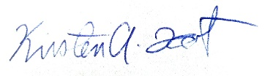 9/30/2019
Faculty Signature Date

